**ASSIGNMENT 1**

**Task 1:** Create a Git repository named as your enrollment number. Create 2 folders in your repository named as Assignment_1 and Assignment_2.

**Step 1 :** First Login to Github Using Your Account.

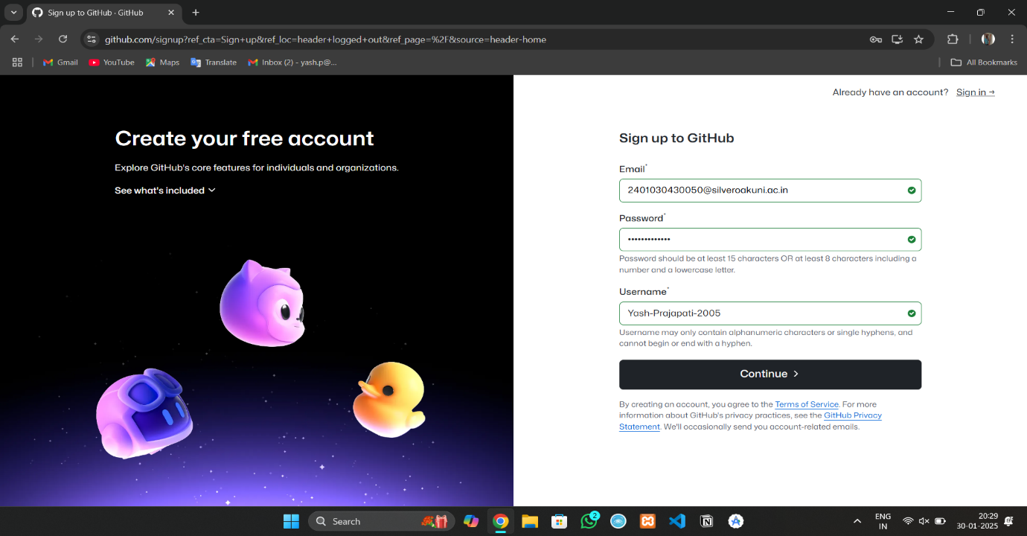

**Step 2 :** This Screen will appear after login now click on create repository to create your repository.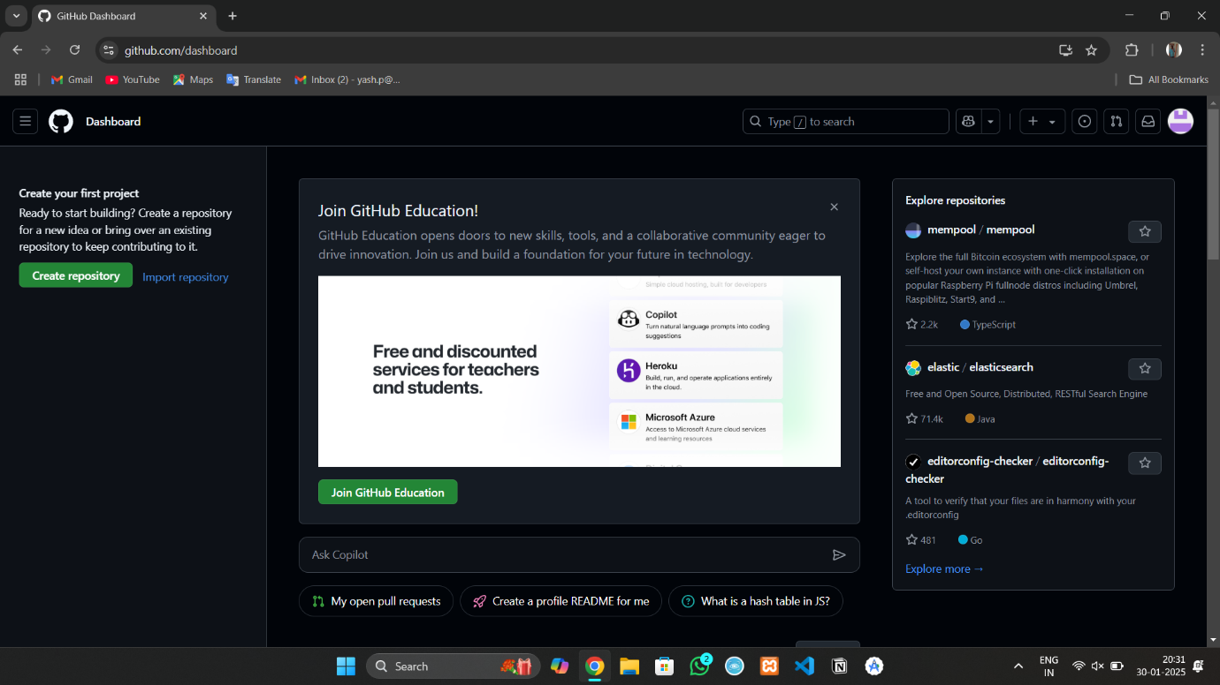

**Step 3 :** Create a Repository as per your Enrollment No.

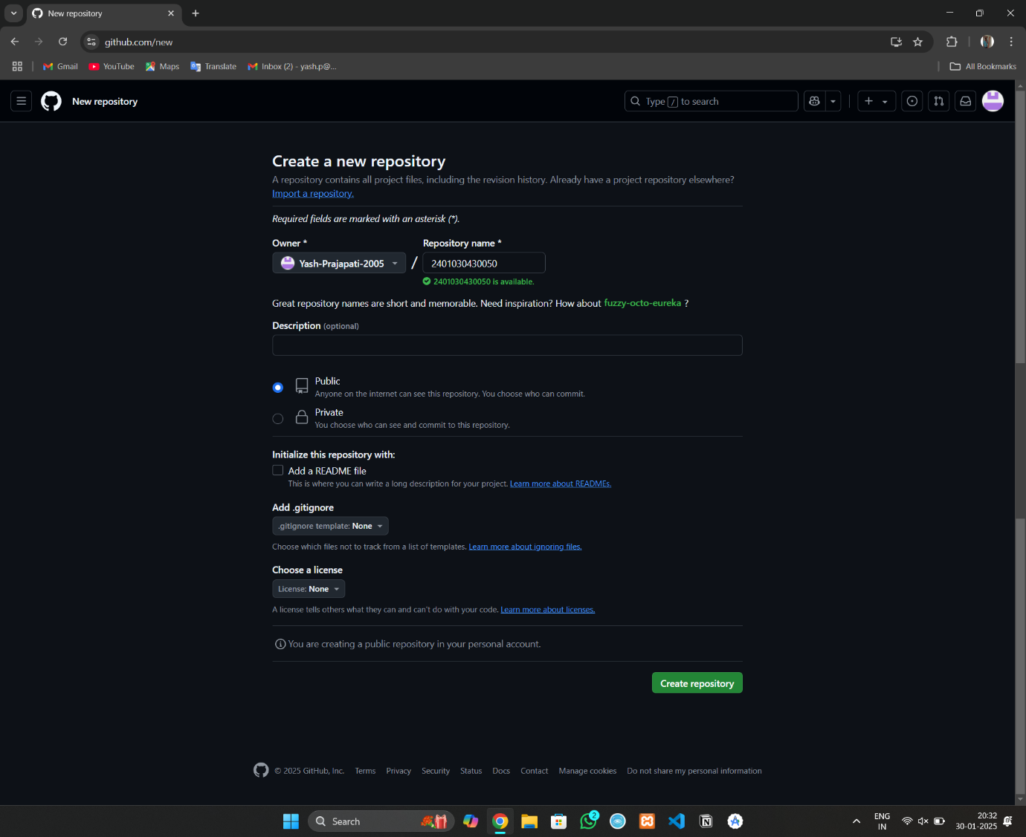

**Step 4 :** Create First folder named as Assignment_1 .

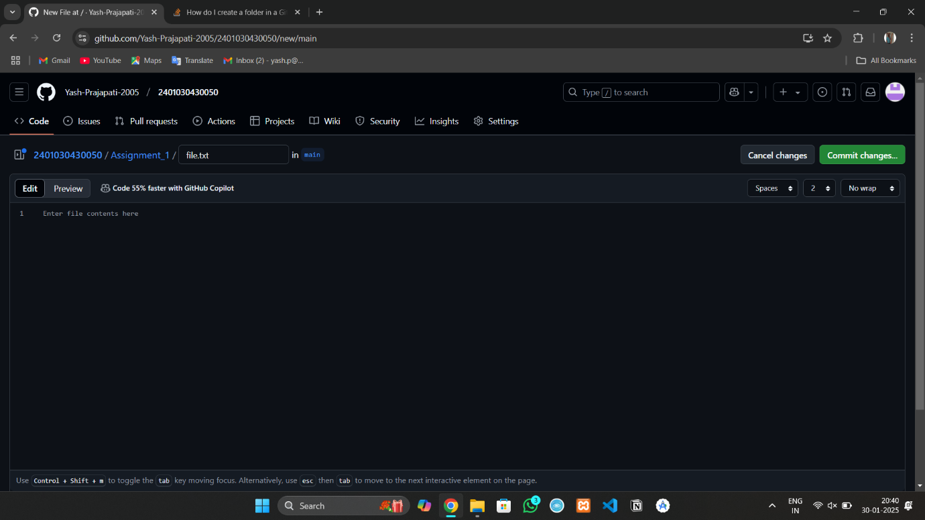

**Step 5 :** Create Second folder named as Assignment_2 .

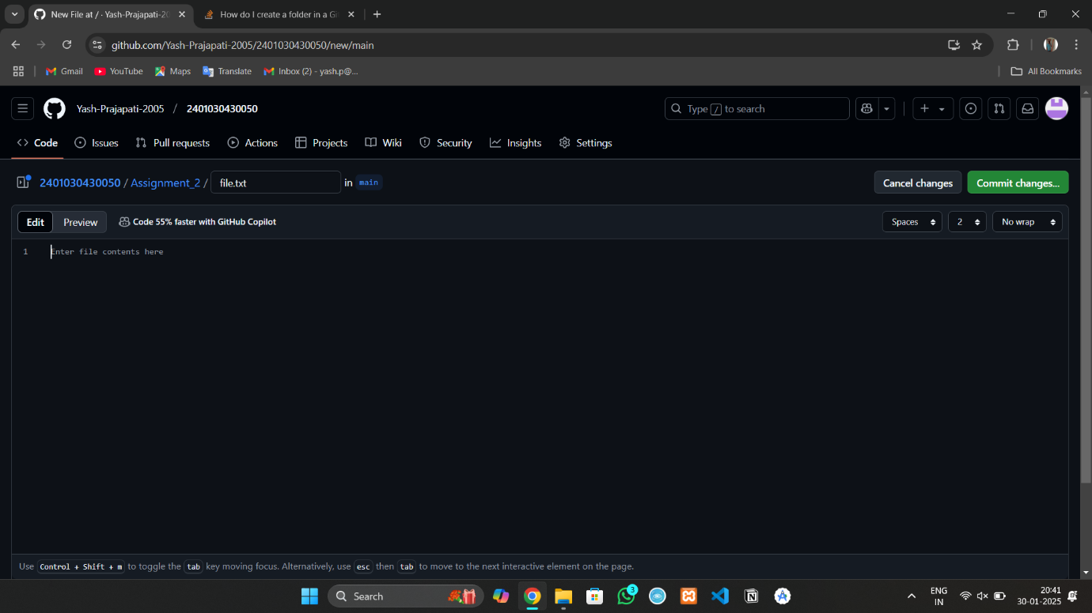

**Step 6 :** Below is the View After Successfully creating All folders.

